EXPT NO: 4 | TRANSFER LEARNING USING PRE-TRAINED VISION MODELS FOR IMAGE RECOGNITION
DATE:

PRE-LAB QUESTIONS (PROVIDE BRIEF ANSWERS TO THE FOLLOWING QUESTIONS)
1. What is transfer learning in deep learning?
Transfer learning is a technique where a model trained on one large dataset is reused for a different but related task. This saves time and requires less training data.
2. What are the advantages of using pre-trained models over training from scratch?
- Saves training time and computational resources.
- Requires less data.
- Usually provides better accuracy.
- Uses already learned useful features.
3. What is the role of fine-tuning in transfer learning?
Fine-tuning means slightly retraining a pre-trained model on a new dataset so that it can adapt better to the specific task.
4. Name any three popular pre-trained computer vision models.
- VGG16
- ResNet50
- MobileNet
5. What is the purpose of Hugging Face and how is it useful in deep learning?
Hugging Face is a platform that provides pre-trained AI models, datasets, and tools. It helps developers easily use, train, and fine-tune models for tasks such as image classification, text processing, and generative AI.

AIM
To implement transfer learning using pre-trained vision models for image recognition and evaluate their performance on real-world image datasets.

SOFTWARE REQUIREMENTS
- Python
- TensorFlow/Keras or PyTorch
- Google Colab
- Hugging Face Transformers
- Kaggle Dataset
- Matplotlib
- GitHub

OBJECTIVES
Students will be able to:
- Understand the concept of transfer learning.
- Apply pre-trained vision models for image recognition.
- Fine-tune models such as ResNet or AlexNet.
- Utilize Kaggle datasets and Hugging Face vision models.
- Compare transfer learning performance with custom CNN models.

PROCEDURE
PART A: DATASET PREPARATION
Perform the following tasks:
- Download an image dataset from Kaggle.
- Load and preprocess the images.
- Split the dataset into training, validation, and testing sets.
CODE:
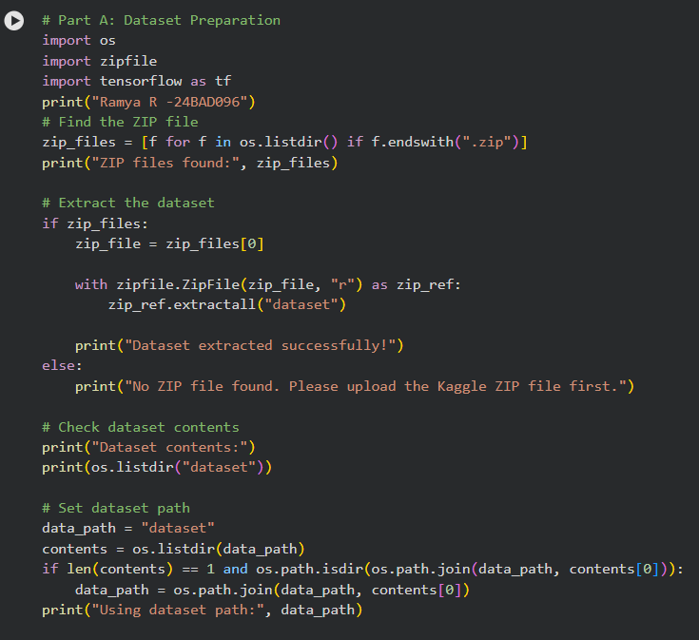
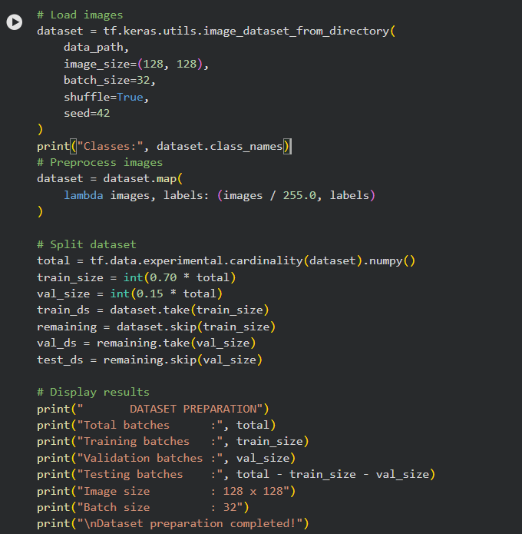
OUTPUT:
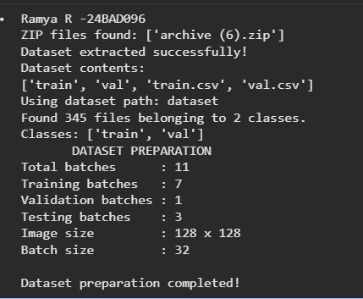

PART B: IMPLEMENTING TRANSFER LEARNING
Load a pre-trained model such as:
- ResNet-50
- AlexNet
Replace the final classification layer according to the dataset classes.
Freeze the feature extraction layers.
Compile the model.

CODE:
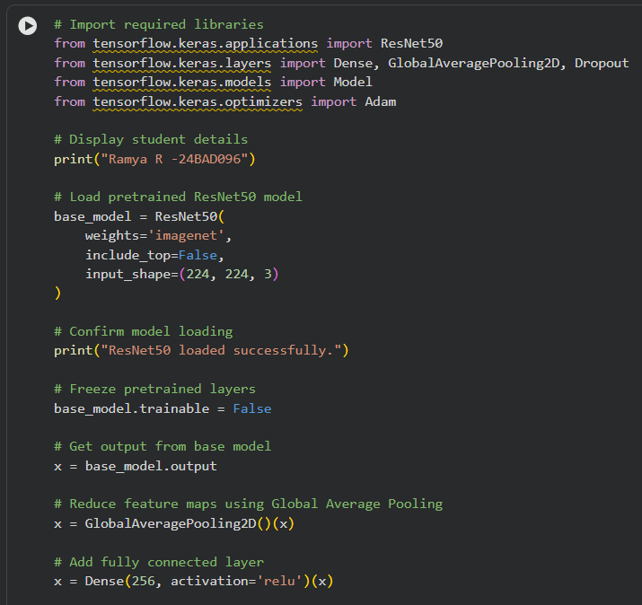

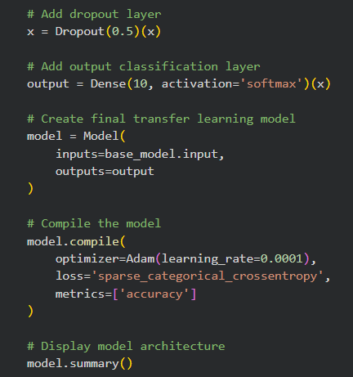

OUTPUT:
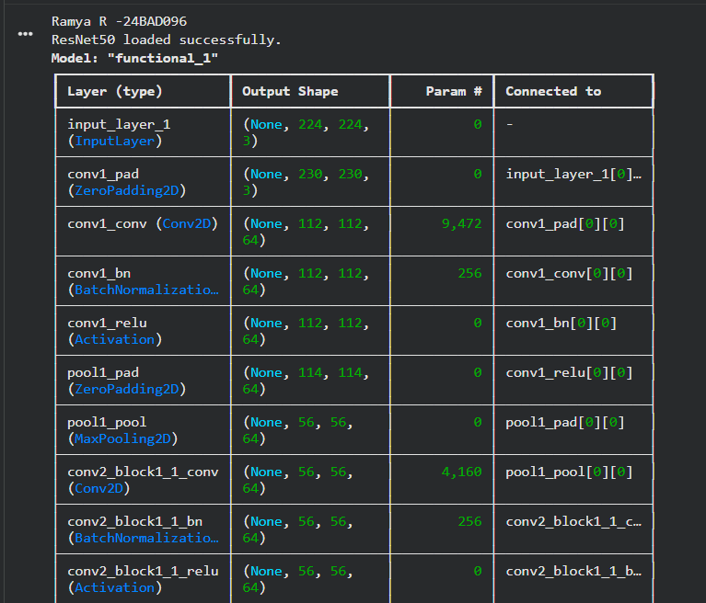
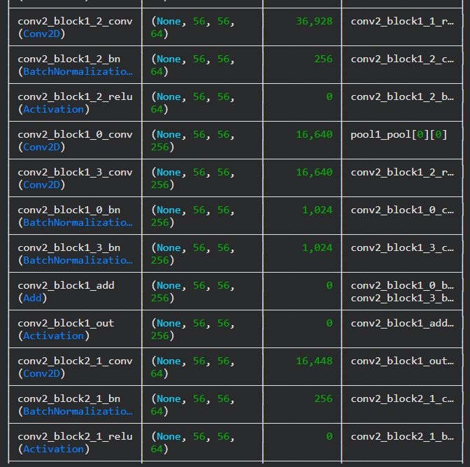
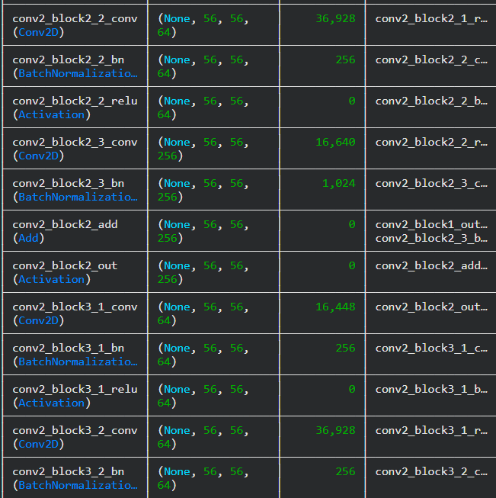
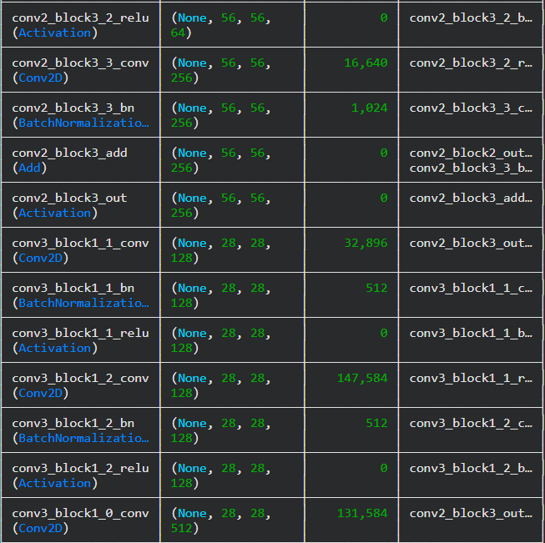

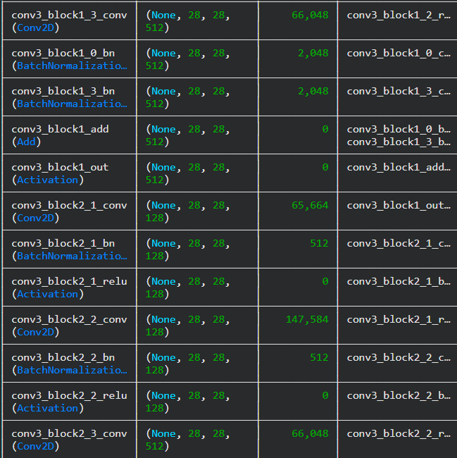
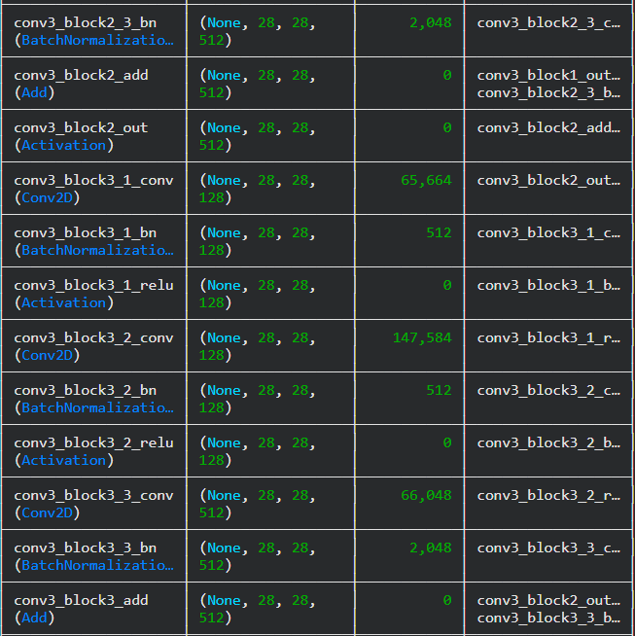
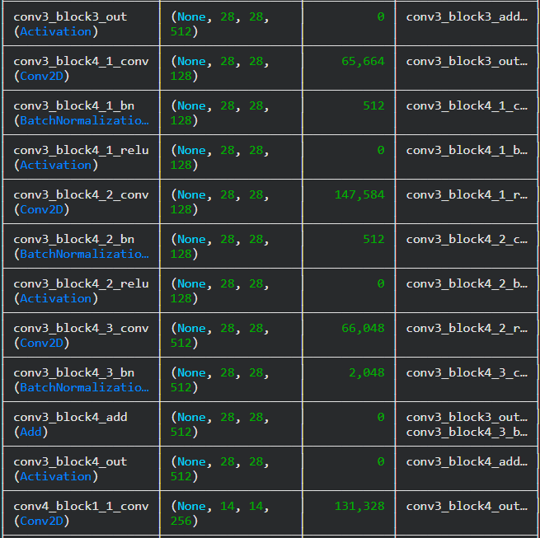
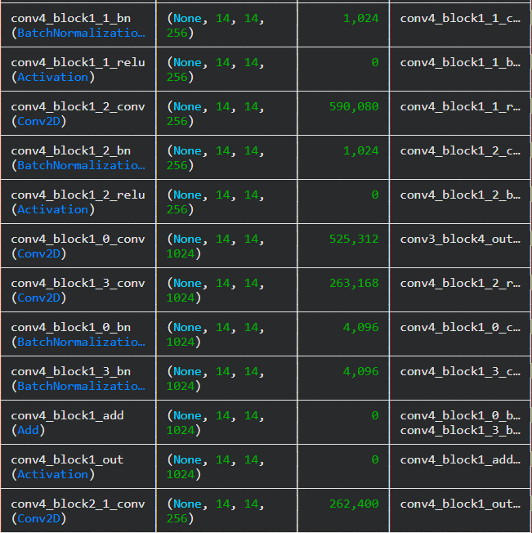

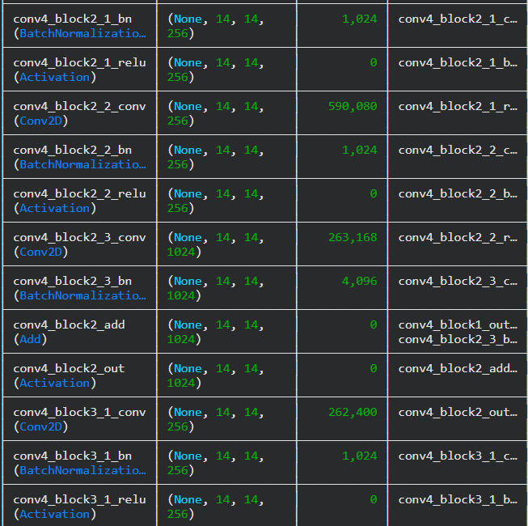
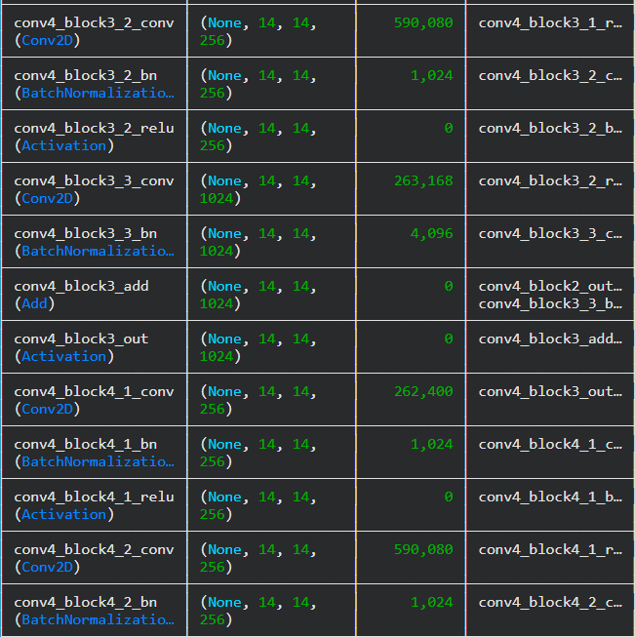
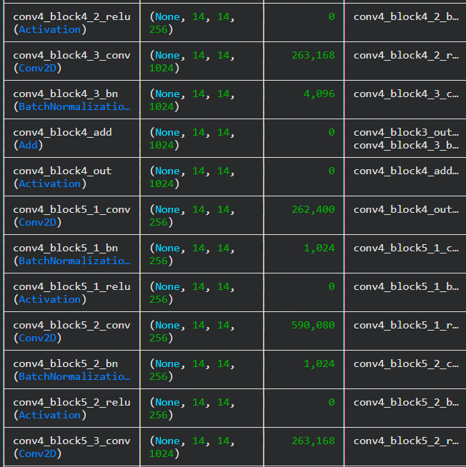
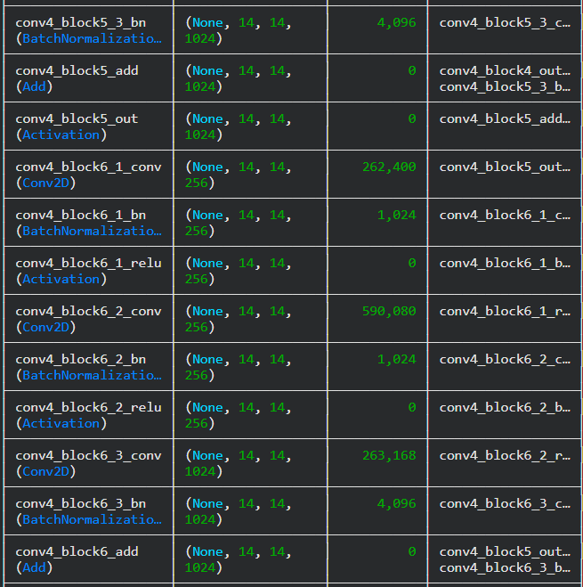
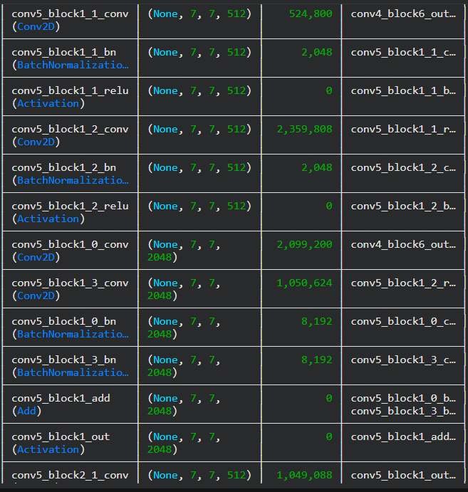
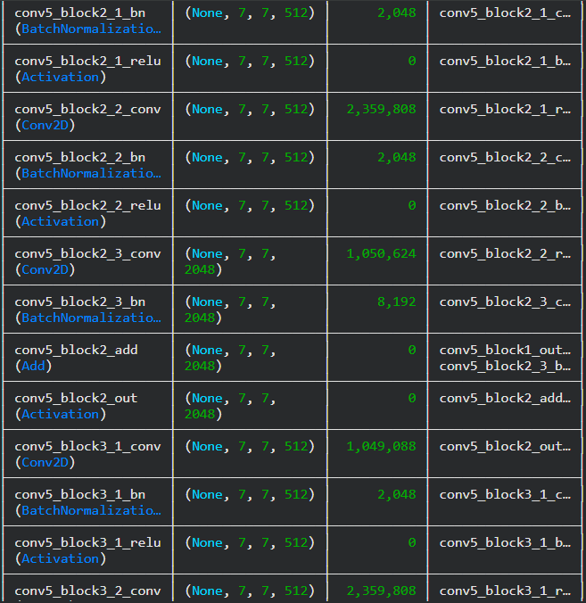

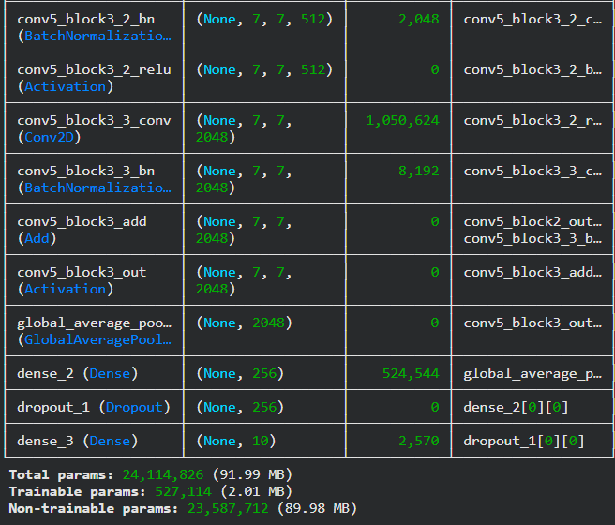

PART C: MODEL TRAINING AND PERFORMANCE EVALUATION
Train the transfer learning model.
Record:
- Training accuracy
- Validation accuracy
- Training loss
- Validation loss
- Test accuracy
Visualize:
- Accuracy vs Epoch
- Loss vs Epoch

CODE:
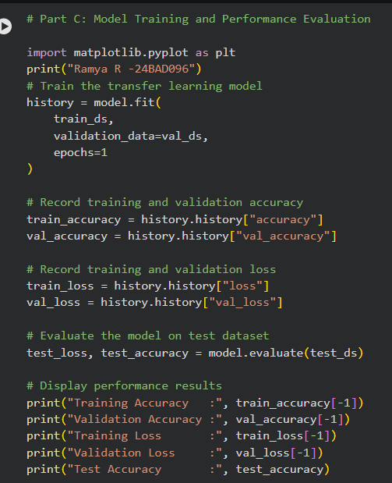
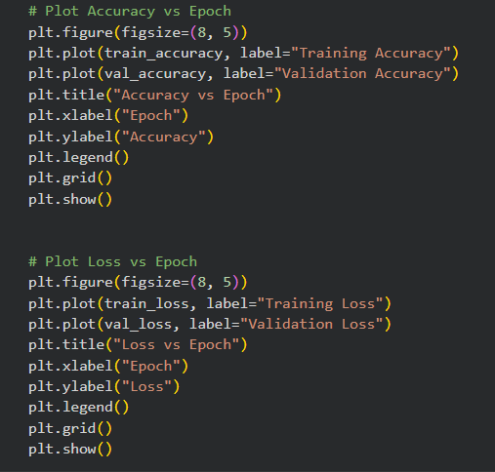

OUTPUT:
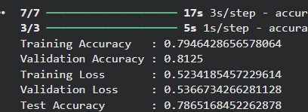
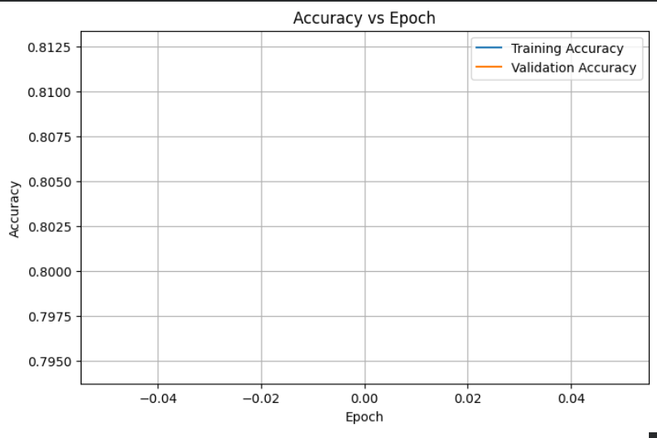

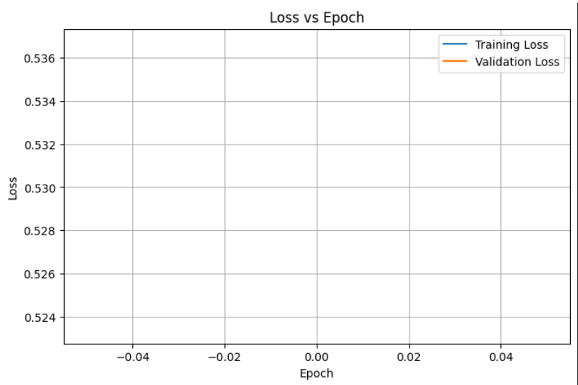

PART D: USING HUGGING FACE PRE-TRAINED MODELS
Perform the following tasks:
- Load a pre-trained vision model from Hugging Face.
- Perform image classification on sample images.
- Compare predictions with the transfer learning model.
- Document observations and upload the notebook to GitHub.
CODE:
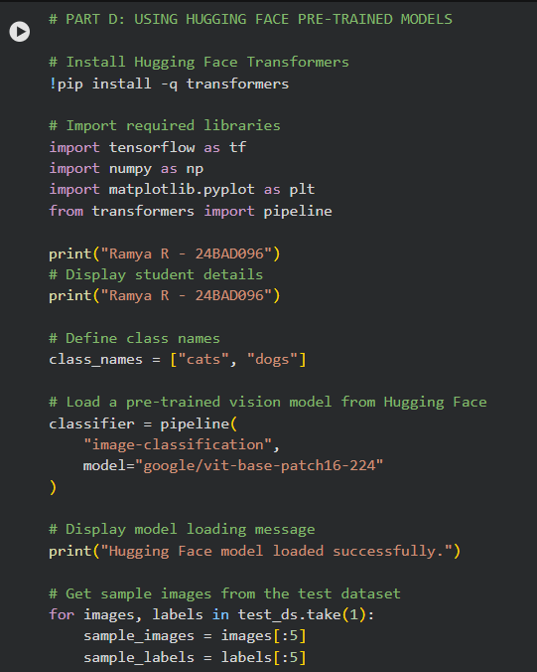

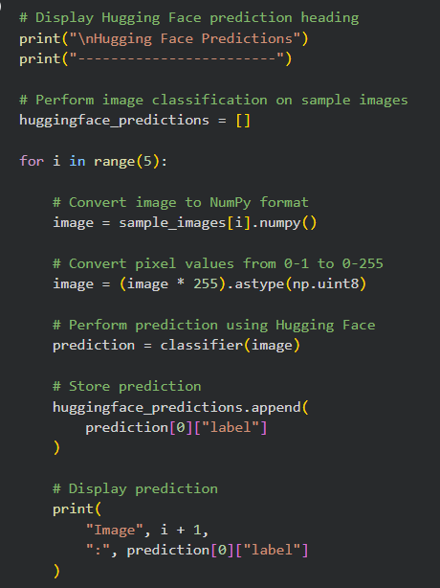
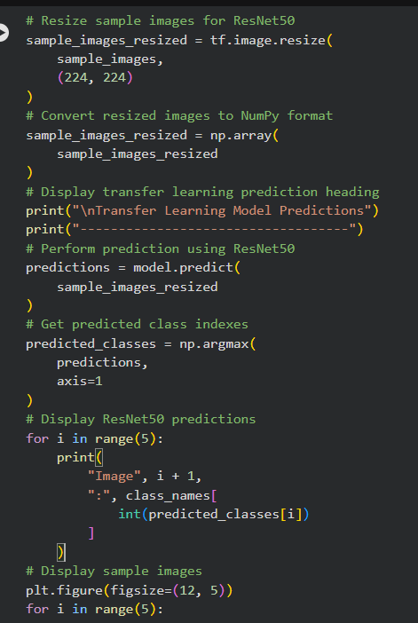

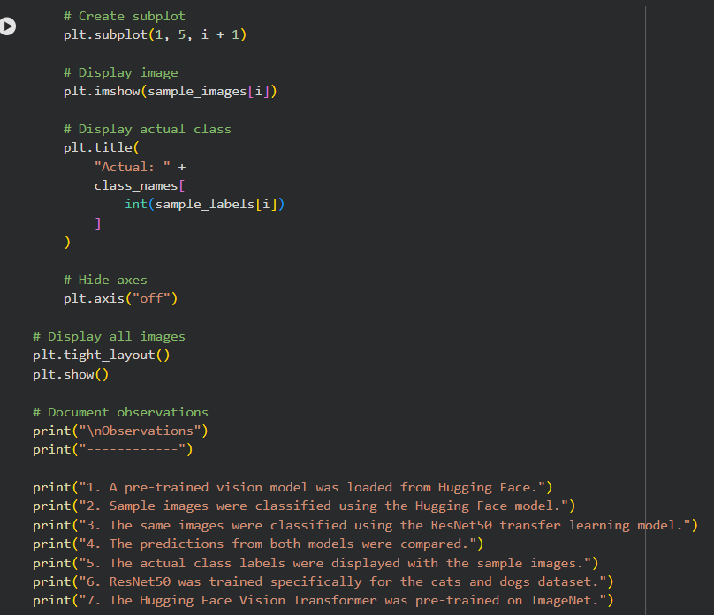

OUTPUT:
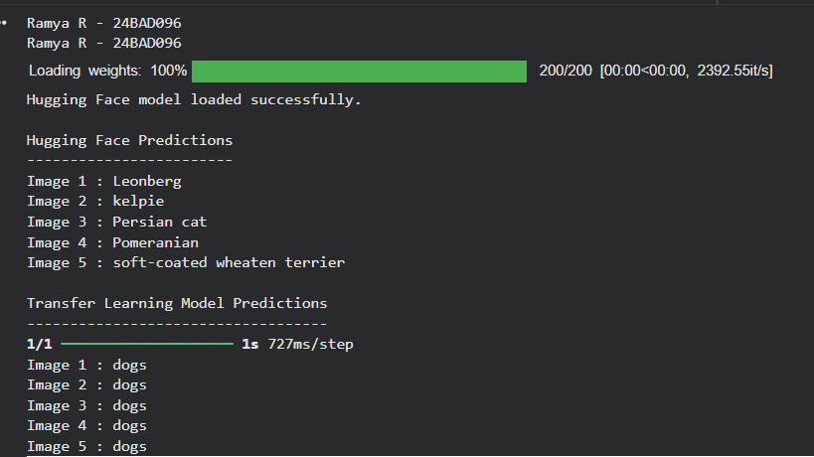
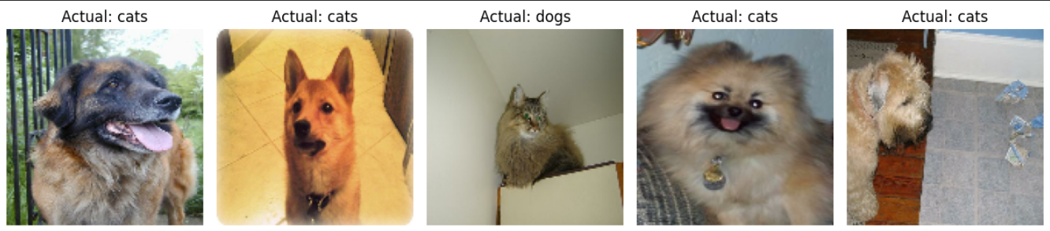

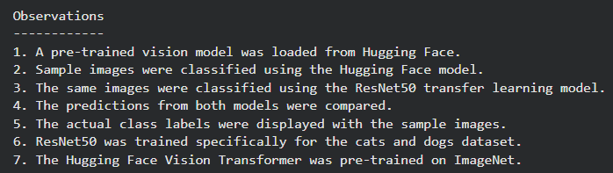

EXPECTED OUTCOME
Students will understand the advantages of transfer learning and gain practical experience in fine-tuning pre-trained vision models from TensorFlow/PyTorch and Hugging Face for image recognition tasks.

POST-LAB QUESTIONS (PROVIDE BRIEF ANSWERS TO THE FOLLOWING QUESTIONS)
1. What are the advantages of transfer learning compared to training a CNN from scratch?
Transfer learning saves time, requires less training data, and usually gives better accuracy because it uses features already learned from a large dataset.
2. Why are pre-trained models able to achieve higher accuracy with fewer training epochs?
Pre-trained models have already learned useful features such as edges, shapes, and patterns from a large dataset. Therefore, they need fewer epochs to learn the new task.
3. Compare the performance of the transfer learning model with the CNN implemented in the previous experiment.
The transfer learning model generally gives higher accuracy and faster convergence than a CNN trained from scratch because it uses pre-learned features.
4. What is the purpose of freezing layers during transfer learning?
Freezing layers prevents their weights from being changed during training. This preserves the useful features learned from the original dataset and reduces training time.
5. How can Hugging Face simplify the deployment and experimentation of vision models?
Hugging Face provides ready-to-use pre-trained vision models, datasets, and tools. It makes it easier to load, test, fine-tune, and deploy vision models without building everything from scratch.

ASSESSMENT
Description | Max Marks | Marks Awarded
Pre Lab Exercise | 5
In Lab Exercise | 10
Post Lab Exercise | 5
Viva | 10
Total | 30
Faculty Signature

